**COMPUTER VISION ASSIGNMENT**

**INTRODUCTION TO OPENCV**

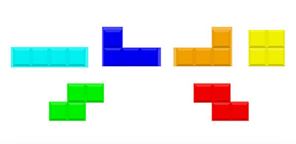

* Read the above using the opencv module.
* Convert the same into grayscale and display it.
* Display the shape of the image.
* Resize the image to (1000x1000) and display it.
* Smoothen an image ( Blur )
* Draw on an image. ( a rectangle around any object, blue solid circle in the middle of the image, draw a green line diagonally across the image)
* Perform Edge Detection using Canny Edge Detection
* Perform Image Thresholding
* Detect and draw contours.

**IMAGE AUGMENTATION**

Perform the following and show the results:

* Mirror the image
* Rotate it clockwise by 30 degrees
* Rotate the image anti-clockwise by 30 degrees
* Add noise to the image
* Add a padding of 10 to each side of the image
* Change the brightness, contrast and hue of the image and show results

**INTRODUCTION TO CNNs**

**1. CIFAR-10 Dataset using CNNs.**

The CIFAR-10 dataset consists of 60,000 32 x 32 colour images in 10 classes, with 6,000 images per class. There are 50,000 training images and 10,000 test images.

Dataset- [CIFAR-10 dataset](https://www.cs.toronto.edu/~kriz/cifar.html)

Using CNN, build an image classification model and show test predictions and accuracy.

**2. Classify the Images of ImageNet using CNNs**

ImageNet is the main database behind the ImageNet Large Scale Recognition Challenge (ILSVRC). The ImageNet dataset has more than 14 million images, hand-labeled across 20,000 categories.

The data is too heavy and thus we have an alternative for it. [Imagenette](https://github.com/fastai/imagenette) is a dataset that’s extracted from the large ImageNet collection of images.

Steps to be followed:

* Download the Dataset
* Loading Images using ImageDataGenerator
* Building a Basic CNN model for Image Classification
* Using Transfer Learning (VGG16,AlexNet etc) to improve accuracy

**ADVANCED COMPUTER VISION**

1. Perform Object Detection using Tensorflow. (model which is trained on the COCO dataset.)
2. Perform Object Detection using YOLOv3.

The weights and the configuration file can be found in this [link](https://pjreddie.com/darknet/yolo/) and the coco-names file can be downloaded from [here](https://github.com/pjreddie/darknet/blob/master/data/coco.names).

1. Perform Face Recognition using Haar cascade